1. End-to-End Model

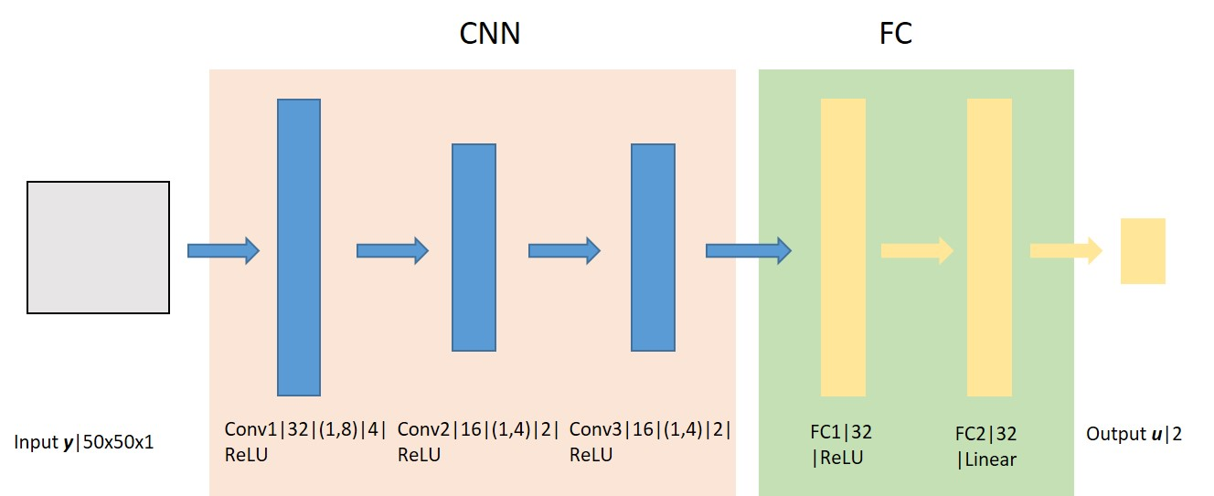

Fig. 1 DNN architecture for robot control policy

Input: 50 by 50 grey scale images (50 x 50 x 1)

Output: 2-dimensional velocity

1. Supervised Training

i) Training set: Training data include the Lidar observation and robot control generated by the model-based controller for each time step *k*, i.e., the 2-tuple (,). Totally 4450 (*k*=4450) time steps of data were collected, which were grouped into batches (mini-batch training).

ii) Loss function for each training step:



Where  is the mini-batch size; is the mapping from observation to control, which is represented by the DNN with parameters ;  is the j-th observation in the mini-batch; is the j-th control in the mini-batch.

iii) Optimizer: Adam optimizer

iv) Training results:



Fig. 2 Loss over episodes

v) Testing

Testing data: Totally 900 (*k*=900) time steps of data were used as testing data. The statistics of errors between the true output in the testing data and the output given by the learned model over 900 data is show as follows.



Fig. 3 The error between true output and output given by learned model

Conclusion:

We can observe convergence of the current training algorithm from Fig. 2, however, it cannot learn a valid mapping from the visual observation to velocity control for the formation control task. Possible reasons include the validity of training data, the design of DNN architecture (especially the CNN, where it can learn useful state representation from the images).

Below are some samples of the training data:

|  |  |
| --- | --- |
|  |  |
|  |  |
|  |  |
|  |  |

Sample results of the model-based controller trying to stabilize an **ideal** model. (No actuator saturation is considered. The robot can instantaneously accelerate to command speed.)

|  |  |
| --- | --- |
|  |  |
|  |  |
|  |  |
|  |  |

|  |  |
| --- | --- |
|  |  |
|  |  |
|  |  |
|  |  |

Sample results of the model-based controller trying to have an **ideal** model track a pre-specified trajectory.

|  |  |
| --- | --- |
|  |  |
|  |  |
|  |  |
|  |  |